

PROJECT

**TOP2121 – OBJECT-ORIENTED PROGRAMMING**

**TRIMESTER 1, 2023/2024 (TERM 2310)**

**Project Title: Point of Sales (POS) Management System**

**Lab Section: 1A**

**Submission Date: 13 February 2024**

|  |  |  |  |
| --- | --- | --- | --- |
| **NO** | **STUDENT ID** | **STUDENT NAME** | **MAJOR** |
|  | 1201101513 | THAM THAO | AI |
|  | 1201102471 | LIEW WEI MING | BIA |
|  | 1201102676 | PHANG AO ZAN | BIA |
|  | 1201102736 | KANG HE YUN | ST |

**Table of Contents**

Introduction 4

Problem Statements 5

Objectives 6

Program Scope 7

Detailed Description 8

System Design 9

Use Case Diagram 9

Class Diagram 10

State Diagram 11

Draft Interface Design 12

Screenshot of the program 15

Reference 40

Appendix 41

Task Distribution

|  |  |  |  |
| --- | --- | --- | --- |
| **No.** | **Student ID** | **Student Name** | **Tasks Completed** |
|  | 1201101513 | THAM THAO | * Discussion with group members and distribute tasks. * Complete distributed tasks. * Compile all the parts for programming, report, and video. |
|  | 1201102471 | LIEW WEI MING | * discussion with group members * fulfilling tasks given by group leader * take part in documentations * take part in coding part for the project * system testing and error fixing with group members |
|  | 1201102676 | PHANG AO ZAN | * discussion with group members * fulfilling tasks given by group leader * take part in documentations. * take part in coding part for the project. * system testing and error fixing with group members. |
|  | 1201102736 | KANG HE YUN | * discussion with group members * fulfilling tasks given by group leader * take part in documentations. * take part in coding part for the project. * system testing and error fixing with group members. |

# Introduction

In today's dynamic business landscape, reliance on manual labor for information storage is increasingly considered antiquated and inefficient. Traditional methods, such as recording information on paper, not only incur significant costs but also lead to issues like data duplication and confusion. The inefficiency is compounded by the substantial storage space required for physical records, posing both logistical challenges and environmental concerns. In response to these challenges, our group is proud to introduce a cutting-edge Point of Sales Management System. This system is designed to empower users in efficiently managing business information and inventory, offering a more sustainable, user-friendly, and time-saving alternative. Key features include customer information retention, product price customization, and a comprehensive record of invoices. By automating tasks that were once prone to human error, our Point of Sales Management System not only enhances operational efficiency but also contributes to a more sustainable and eco-friendly business environment. Embracing this technology is not just a smart idea; it's a strategic imperative to stay competitive in the modern era. The intuitive user interface of our system further sets it apart from conventional software packages, ensuring swift navigation and seamless integration into daily business operations. It is our firm belief that by adopting this innovative solution, businesses can not only streamline their processes but also stay ahead in this fast-paced and ever-evolving business landscape.

# Problem Statements

The main goal of the POS system is to solve problems which the users encountered by storing data with human power such as:

* Waste of resources: It is a waste of resources to record information using conventional techniques like a pen and pencil.
* Inconsistent data: The data on customers, inventory, invoices, and income may not be consistent due to human error when recording information.
* Lack of efficiency: An excessive number of tasks carried out by the user manually may result in inefficiency.

The information that is manually stored, such as entries in a book or paper, which requires labor, will waste resources if there is no Point-of-Sale management system. Occasionally, incorrect data might also result from using manpower to manually record the information. Additionally, looking for a certain piece of information manually across a series of documents takes time and is inefficient.

# Objectives

A point-of-sale (POS) system is an essential tool used in various industries to facilitate transactions. When creating a POS system using Java, there are several objectives that need to be addressed. These objectives include:

**User-Friendly Interface**

The POS system will feature a user-friendly interface that allows for easy navigation and data entry. This will enable the user to effortlessly perform various sales transactions, such as adding items to the cart, processing payments, and generating receipts.

**Cost-Effectiveness:**

Java is an open-source programming language, which means it is free to download and use. Developing a POS system using Java can significantly reduce upfront licensing costs and long-term maintenance expenses.

**Data Management:**

A well-designed POS system needs to handle large amounts of data efficiently. The system allows businesses to analyze sales data, generate reports, and make data-driven decisions to optimize business performance.

**Flexibility and Customization:**

Each business has its unique requirements. A Java-based POS system allows for customization and tailoring to meet specific business needs. Java's modular architecture enables developers to add new features, modify existing ones, and create tailored solutions that address the specific requirements of a business.

**Efficiency and Accuracy:**

Java provides a robust and scalable platform that can easily handle high volumes of transactions. By using Java, the POS system can be designed to perform calculations, maintain data integrity, and ensure accurate record-keeping.

# Program Scope

By using the Point of Sales (POS) system, the user can carry out simple tasks such as calculating total price in the cart, recording data of the products, recording of customer information, recording invoice details, and keeping track of income from the POS. These tasks will be easier to carry out and more convenient when users use this POS system. Users can insert, delete, and modify data in this POS system.

**Features of POS system**

* Efficient Transaction Processing
* Inventory Management
* Customer Information Management
* Invoice Management
* Income Tracking

# Detailed Description

**Login Screen:** Users must register to login to our system.

**Home Page:** User is able to select different buttons that navigate to different pages that have different functions.

**Point of Sales Page:** User is able to carry out payment activities in this page.

**Customer Page:** User can add, delete, and update customers’ information and view them in table form.

**Product Page:** User can add, delete, and update products’ information and view them in table form.

**Income Page:** User can keep track of the income that been made by this POS which data is been recorded in a text file.

**Invoice Page:** User can add, delete, and update invoices’ information and view them in table form.

# System Design

## Use Case Diagram

## Class Diagram

## State Diagram

## Draft Interface Design

Login Page

Register Page

Home Page

POS Page

Customer Page

Product Page

Invoice Page

Income Page

# Screenshot of the program

**Login page**

When the user keys in the command to start the system, the login page will come out.

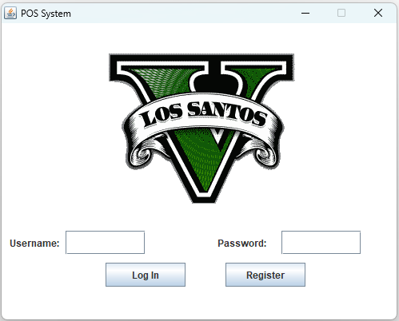

**Register Page**

If the user didn’t have the account to login, the user can click the ‘Register button’, and the registration form will come out.

The user must fill in the details to register as a new user.

If the user is successfully registered as a new user, a message of successful registration will pop out.

If the user did not fulfill the requirements to register as a new user, an error message will pop out, and the user will be needed to register again.

Then the user can use the new user details to login. Once the user is logged in successfully, the system will go to the home page.

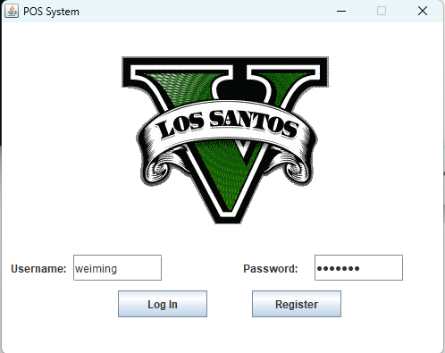

**Home Page**

This is the Home page of our POS management system. User can click on the button on the main site or click on the tab on the side bar to navigate to desired page.

**POS Page**

Users will be directed to POS page when they clicked the POS button on home page or Point of Sales button on the side tab.

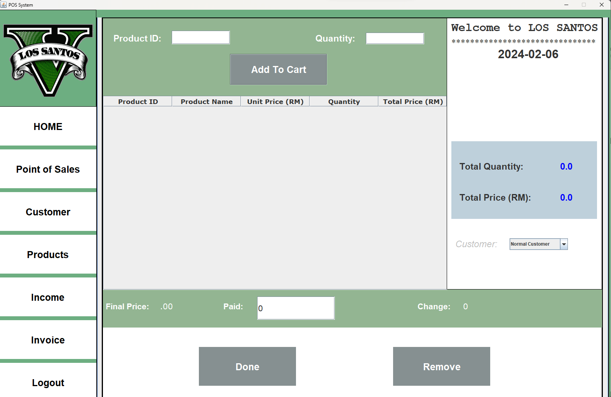

User is required to key in the product ID and quantity before adding the item into the cart by clicking Add To Cart button.

The system will show an error message if the Product ID or Quantity is not entered.

The right bar will show the quantity of items in the cart and show the total price. In this tab, users can choose whether the customer is a member or not. A member will receive a 7% discount.

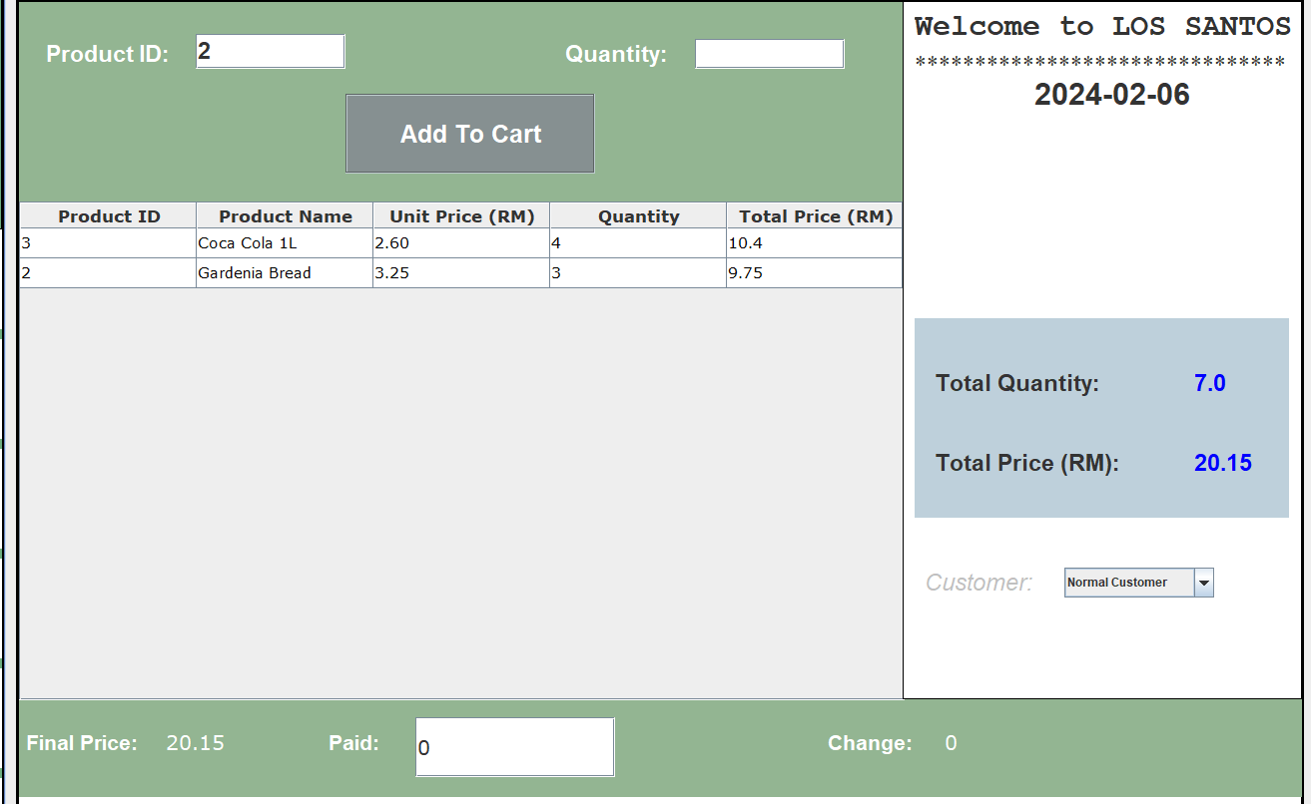

*The final price is the price after the discount.

User can remove the item in the cart by clicking the item in the table and click Remove button.

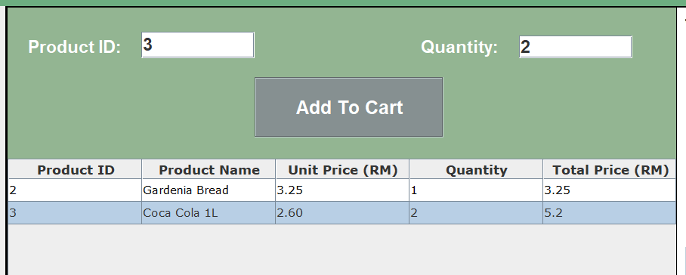

Users had to enter the amount of money that is greater or equal to the final price to complete the payment process. Users had to click the Done button to complete the payment process.

*An error message will pop out if the entered amount is less than final price.

**Customer Page**

Users can go to the Customer Page to view or edit the customer information.

User can input the customer information of prepared.

After the user fill in all blanks, press the add button to add customer information.

For the customer id and contact only can input number

For the customer gender only can input f/m

For the customer contact should be up to 10 digits

For the customer email should be “xxx@xxx.com”, must include “@” and “.com”

Users can use the update button to update selected customer information.

After user press the update button

Users can use the search bar to search the customer information they want to find by input the customer information such as id, name, contact and so on.

Users can use the delete button to delete the customer information they choose.

After user press the delete button

**Product Page**

Users can go to the Product Page to view or edit the product information.

Users can input the product information to the blanks.

After the user fills in all blanks, press the add button to add customer information.

For the product id, price and quantity only can input number.

User must fill the all blanks.

For the inventory date must input “YYYY-MM-DD”

Users can use the update button to update selected product information.

After user press the update button

Users can use the search bar to search for the product information they want to find by input the customer information such as id, name, date and so on.

Users can use the delete button to delete the product information they choose.

After user press the delete button

**Income Page**

Users can direct to Income Page to view the income of the POS by clicking Income button in home page or Income button on the side bar.

Users can click on the Refresh button to show the details of income.

Users can select the date to view the income of the selected date on the search bar. Users also can view the income contributed by certain items.

**Invoice Page**

Users can go to the Invoice Page to view or edit the invoice.

Users can input the invoice to the blanks.

After the user fills in all blanks, press the add button to add invoice.

For the Invoice number, price and quantity only can input number.

Users must fill all blanks.

For the invoice date must input “YYYY-MM-DD”

Users can use the update button to update selected invoice.

After user press the update button

Users can use the search bar to search for the product information they want to find by input the invoice number.

Users can use the delete button to delete the product information they choose.

After user press the delete button

# Reference

<https://www.decipherzone.com/blog-detail/java-pos-guide>

<https://www.w3schools.com/java/>

<https://www.geeksforgeeks.org/file-class-in-java/?ref=lbp>

# Appendix

Part of the code

